🚀 AI SDLC Guardian

AI-Powered Release Intelligence & Software Delivery Risk Assessment Platform
AI SDLC Guardian is an intelligent software release governance platform that uses multiple AI agents to evaluate release readiness, identify risks, and provide actionable recommendations before production deployment.
The platform helps engineering teams, QA teams, DevOps engineers, release managers, architects, and security teams make informed release decisions by automatically analysing requirements, development changes, testing coverage, security posture, compliance readiness, reliability concerns, and operational risks.

Problem Statement
Modern software releases often suffer from:
- Incomplete requirement analysis
- Insufficient QA coverage
- Security vulnerabilities
- Compliance violations
- Reliability risks
- Lack of release governance
- Manual review bottlenecks
Organisations frequently rely on subjective release decisions, leading to production incidents, security breaches, compliance issues, and failed deployments.

Solution
AI SDLC Guardian introduces an AI-driven multi-agent review system that automatically evaluates software releases across multiple dimensions and provides a final release recommendation.
The platform acts as an intelligent release governance layer between development and production deployment.

Key Features

Multi-Agent Release Analysis
Specialised AI agents independently analyse:

Requirement Intelligence
- Requirement quality analysis
- Missing requirement detection
- Architectural risk identification
- Requirement completeness scoring

Development Intelligence
- Missing implementation detection
- Technical risk analysis
- Future defect prediction
- Development readiness scoring

QA Intelligence
- Test coverage assessment
- Missing test scenario detection
- High-risk testing gap identification
- QA readiness scoring

Security Intelligence
- Vulnerability identification
- Authentication risk analysis
- Authorization risk analysis
- API security assessment
- Data protection review
- Security scoring

Performance Intelligence
- Performance risk detection
- Scalability assessment
- Database risk analysis
- Load testing recommendations

Business Impact Intelligence
- Customer impact analysis
- Business risk assessment
- Operational impact review
- Business readiness scoring

Observability Intelligence
- Logging gap analysis
- Monitoring assessment
- Alerting coverage review
- Audit trail evaluation

Reliability Intelligence
- Single point of failure detection
- Availability assessment
- Dependency risk analysis
- Recovery readiness evaluation

Compliance Intelligence
- Compliance violation detection
- Audit gap analysis
- Data privacy assessment
- Regulatory risk evaluation

Release Intelligence Engine
The platform aggregates findings from all specialist agents and produces:
- Release Confidence Score
- Overall Risk Score
- Risk Level
- Release Recommendation
Possible outcomes:

GO
Release is ready for production.

GO_WITH_RISK
Release can proceed with documented risks.

NO_GO
Critical blockers prevent deployment.

Risk Center
Provides enterprise-grade risk visibility:
- Risk heatmaps
- Domain risk analysis
- High-risk release identification
- Critical blocker tracking
- Action prioritization

AI Insights
Generates historical intelligence:
- Release trends
- Confidence analytics
- Risk distribution
- Most common blockers
- Domain health metrics

Reports Engine
Automatically generates:
- Executive release reports
- Security reports
- Performance reports
- Compliance reports
- QA readiness reports

Release History
Stores and tracks:
- Historical release assessments
- Risk scores
- Recommendations
- Actions required
- Executive summaries

System Architecture
User
↓
Frontend (Lovable + React)
↓
n8n Workflow Orchestration
↓
AI Multi-Agent Layer
├─ Requirement Agent
├─ Development Agent
├─ QA Agent
├─ Security Agent
├─ Performance Agent
├─ Business Agent
├─ Observability Agent
├─ Reliability Agent
├─ Compliance Agent
└─ Release Intelligence Agent
↓
Risk Aggregator
↓
MongoDB Atlas
↓
History API
Insights API
Reports API
Risk Centre API

ARCHITECTURE DIAGRAM

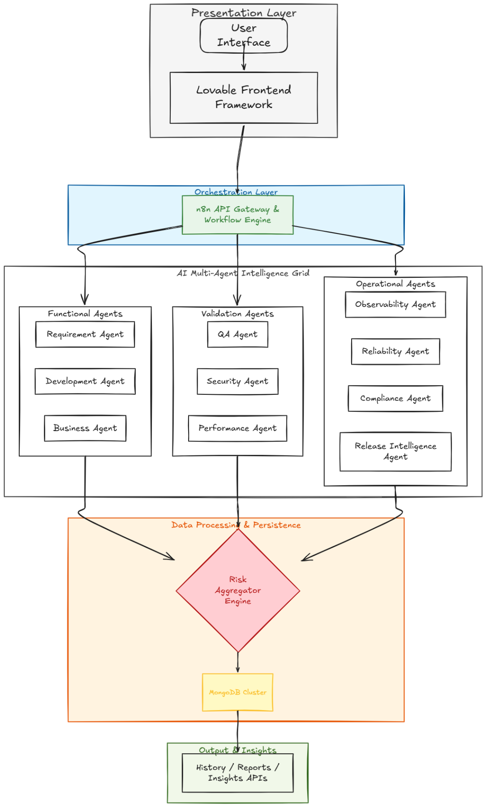

Technology Stack

Frontend
- React
- TypeScript
- Tailwind CSS
- Lovable

Backend
- n8n Workflow Automation
- OpenAI
- Multi-Agent Architecture

Database
- MongoDB Atlas

APIs
- REST APIs
- Webhook Architecture

API Endpoints

Analyze Release
POST /analyse-project
Performs a complete AI-powered release assessment.

Release History
GET /release-history
Returns historical release assessments.

AI Insights
GET /ai-insights
Returns analytical insights from historical release data.

Reports
GET /reports
Returns executive and operational reports.

Risk Center
GET /risk-centre
Returns risk analytics and risk intelligence.

Health Check
GET /health
Returns platform health status.

Release Details
GET /release-details
Returns detailed information about a specific release.

Security
The platform includes:
- Secure backend authentication
- Server-side secret management
- Protected webhook communication
- Secure API architecture
- Input validation
- Error handling
- Defensive programming practices

Future Roadmap
- GitHub Integration
- GitLab Integration
- Jira Integration
- Azure DevOps Integration
- CI/CD Pipeline Integration
- Sprint Intelligence
- Agile Readiness Scoring
- Automated Pull Request Reviews
- Predictive Release Failure Detection
- Release Failure Analytics
- Enterprise Governance Dashboards

Business Impact
AI SDLC Guardian helps organisations:
- Reduce production failures
- Improve release confidence
- Detect risks earlier
- Strengthen DevSecOps practices
- Improve compliance readiness
- Accelerate release approvals
- Standardise release governance

My Vision
My vision is to build an AI-powered software delivery governance platform that enables organisations to ship software faster, safer, and with greater confidence through intelligent release intelligence and automated risk assessment.

Hackathon Submission
AI SDLC Guardian demonstrates how AI agents can transform traditional software delivery processes into an intelligent, automated, and risk-aware release governance system.
Built for modern engineering teams embracing DevOps, DevSecOps, Agile, and continuous delivery practices.

